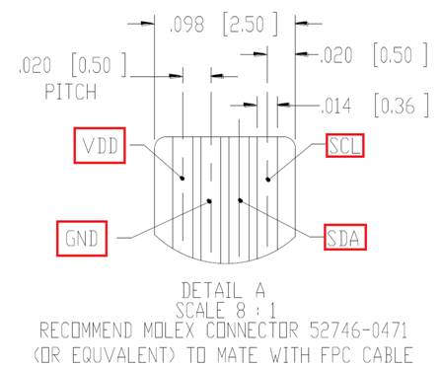

Pin 1 – VDD Pin 2 – GND Pin 3 – SDA Pin 4 – SCL

